

**Western Australian Certificate of Education**

**ATAR course examination, 2019**

**Question/Answer Booklet**

12 PHYSICS

Name

**Test 2 – Gravitation & Equilibrium**

|  |  |  |  |  |  |  |  |  |  |  |
| --- | --- | --- | --- | --- | --- | --- | --- | --- | --- | --- |
| Student Number: In figures |  |  |  |  |  |  |  |  |  |  |

**Mark: $\frac{}{\text{42}}$**  In words

#### Time allowed for this paper

Reading time before commencing work: five minutes

Working time for paper: fifty minutes

**Materials required/recommended for this paper**

To be provided by the supervisor

This Question/Answer Booklet

Formulae and Data Booklet

***To be provided by the candidate***

Standard items: pens, (blue/black preferred), pencils (including coloured), sharpener, correction fluid/tape, eraser, ruler, highlighters

Special items: non-programmable calculators satisfying the conditions set by the School Curriculum and Standards Authority for this course

**Important note to candidates**

No other items may be taken into the examination room. It is your responsibility to ensure that you do not have any unauthorised notes or other items of a non-personal nature in the examination room. If you have any unauthorised material with you, hand it to the supervisor before reading any further.

**Structure of this paper**

|  |  |  |  |  |  |
| --- | --- | --- | --- | --- | --- |
| Section | Number of questions available | Number of questions to be answered | Suggested working time  (minutes) | Marks available | Percentage of exam |
| Section One:  Short Answers | - | - | - | - | - |
| Section Two:  Problem-solving | 8 | 8 | 50 | 42 | 100 |
| Section Three:  Comprehension | - | - | - | - | - |
|  |  |  |  | **Total** | 100 |

**Instructions to candidates**

1. The rules for the conduct of examinations at Holy Cross College are detailed in the College Examination Policy*.* Sitting this examination implies that you agree to abide by these rules.

2. Write your answers in this Question/Answer Booklet.

3. Working or reasoning should be clearly shown when calculating or estimating answers.

4. You must be careful to confine your responses to the specific questions asked and to follow any instructions that are specific to a particular question.

5. Spare pages are included at the end of this booklet. They can be used for planning your

responses and/or as additional space if required to continue an answer.

• Planning: If you use the spare pages for planning, indicate this clearly at the top of the page.

• Continuing an answer: If you need to use the space to continue an answer, indicate in the original answer space where the answer is continued, i.e. give the page number. Fill in the number of the question(is) that you are continuing to answer at the top of the page.

6. Answers to questions involving calculations should be ***evaluated and given in decimal***

***form*.** It is suggested that you quote all answers to ***three significant figures***, with the

exception of questions for which estimates are required. Despite an incorrect final result, credit may be obtained for method and working, providing these are ***clearly and legibly set out***.

7. Questions containing the instruction "estimate" may give insufficient numerical data for their solution. Students should provide appropriate figures to enable an approximate solution to be obtained. Give final answers to a maximum of two significant figures and include appropriate units where applicable.

8. Note that when an answer is a vector quantity, it must be given with magnitude and direction.

9. In all calculations, units must be consistent throughout your working.

1. The Hubble Space Telescope (mass 1.16 x 104 kg) orbits the earth in a circular orbit

6.10 x 102 km above the surface of the earth.

(a) Calculate the gravitational force of attraction between the earth and the telescope.

(3 marks)

(b) Calculate the period (T) of the space telescope about Earth. (3 marks)

2. Given that the period of orbit of the moon is 27.3 days, determine the period of the International Space Station, which has a mass of 7.50 tonne, given that the radius of its orbit is 10.0% (0.100) of the Earth-Moon radius.

(4 marks)

3. Deimos is a small moon that orbits Mars. It has a mass of 1.48 x 1015 kg and orbits at a mean distance of 2.35 x 107 m from the centre of the planet. Its period of orbit is 30.3 hours.

(a) Use this information to determine the mass of the planet Mars.

(3 marks)

(b) The Mars Survey Orbiter was placed in a stable orbit above Mars during a NASA mission. It was given a period of revolution of 135 minutes. Given the radius of Mars is 3.39 x 106 m, determine the height of the orbiter above the surface of the planet.

(3 marks)

(c) What would be the acceleration due to gravity on the surface of Mars?

(3 marks)

4. People with severe arthritis in their hands often have difficulty turning taps on and off. A tap- making company has recognised this and developed a device that fits over the tap and has two arms as shown in the diagram below. Explain the principle upon which this works.

(3 marks)

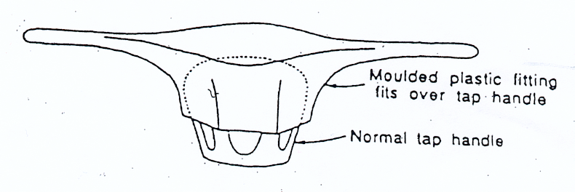

5. A long-handled shovel 1.80 m long is leaning against a smooth wall in the Maintenance Shed. It has a mass of 3.50 kg and its centre of mass is 60.0 cm from the bottom. Assuming the handle and shovel forms a straight line, calculate the reaction force exerted by the wall if the handle is 25.0° to the wall.

(4 marks)

25.0°

6. An 85.0 kg painter is standing on a plank, which rests on two trestles, while painting the upper section of a wall. Assume that the plank is uniform and has a mass of 15.0 kg.

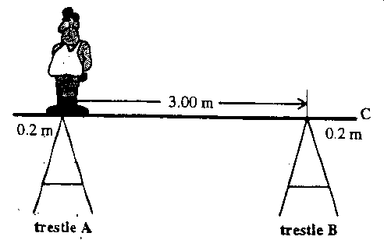

Calculate the forces exerted by each trestle on the plank if the painter stands at trestle A. (5 marks)

7. You are designing a pot plant shelf that can hang from a single point. The shelf has a mass of 3.50 kg and is 1.40 m in length and you allow for three plants with masses no more than 2.50 kg each. Determine the tension in each of the cables. (4 marks)

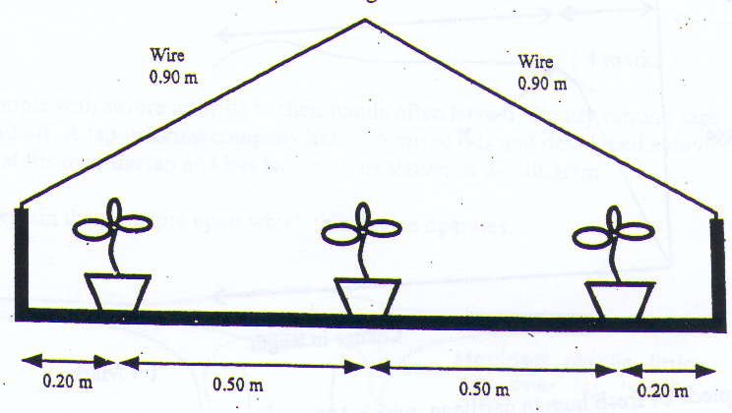

8. The diagram below shows how a set of traffic lights can be suspended from a building at the side of a road. Copper wire holds the 5.00 m long uniform rigid pole in place. The wire is horizontal and attached to the wall at bracket A and the pole is attached to the wall at bracket B. The pole weighs 54.0 N and the traffic lights weigh 2.00 x 102 N. Other dimensions are shown in the diagram.

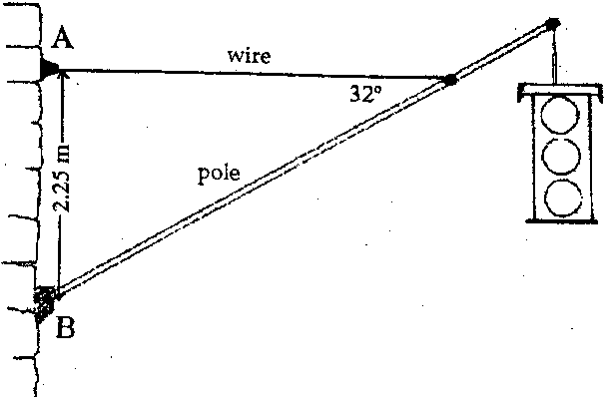

(a) Find the magnitude of the tension force that the wire exerts on the pole.

(4 marks)

(b) Determine the reaction force exerted at bracket B by the wall onto the pole.

(3 marks)